**PIZZA SALES QUERIES**

**A.KPI**

**1.Total revenue**

SELECT SUM(quantity*unit_price) AS Total_revenue

FROM pizza_sales

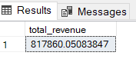

**2. Average Order Value**

SELECT (SUM(quantity*unit_price)/COUNT(DISTINCT order_id)) AS Average_order_value

FROM pizza_sales;

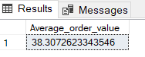

**3.Total Pizza Sold**

SELECT SUM(quantity) AS Total_pizza_sold

FROM pizza_sales;

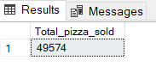

**4.Total Orders Placed**

SELECT COUNT(DISTINCT order_id) AS Order_placed

FROM pizza_sales;

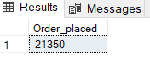

**5. Average Pizzas Per Order**

SELECT (SUM(quantity)/COUNT(DISTINCT order_id) ) AS Average_pizza_perorder

FROM pizza_sales;

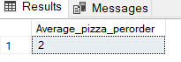

**B. Daily Trend for Total Orders**

SELECT DATENAME(w,order_date) AS Order_day,COUNT(DISTINCT order_id) AS Total_orders

FROM pizza_sales

GROUP BY DATENAME(w,order_date)

ORDER BY COUNT(DISTINCT order_id) DESC;

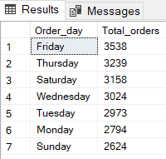

**C. Hourly Trend for Orders**

SELECT DATEPART(hh,order_time) AS Order_hours,COUNT(DISTINCT order_id) AS Total_orders

FROM pizza_sales

GROUP BY DATEPART(hh,order_time)

ORDER BY DATEPART(hh,order_time);

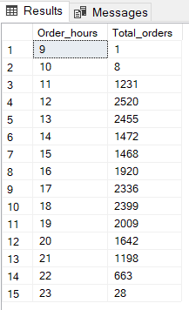

**D. % of Sales by Pizza Category**

SELECT pizza_category,ROUND(SUM(total_price),2) AS pizza_sales,ROUND(SUM(total_price)*100/(SELECT SUM(total_price) FROM pizza_sales),2) AS category_percentage_sales

FROM pizza_sales

GROUP BY pizza_category;

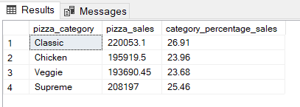

**E. % of Sales by Pizza Size**

SELECT pizza_size,ROUND(SUM(total_price)*100/(SELECT SUM(total_price) FROM pizza_sales),2) AS size_percentage_sales

FROM pizza_sales

GROUP BY pizza_size;

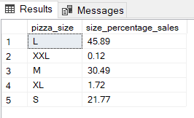

**F. Total Pizzas Sold by Pizza Category**

SELECT pizza_category,SUM(quantity) AS total_sales_percategory

FROM pizza_sales

GROUP BY pizza_category;

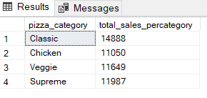

**G. Top 5 Best Sellers by Total Pizzas Sold**

SELECT TOP 5 pizza_name,SUM(quantity) AS pizza_sold_name

FROM pizza_sales

GROUP BY pizza_name

ORDER BY SUM(quantity) DESC;

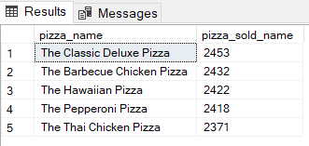

**H. Bottom 5 Best Sellers by Total Pizzas Sold**

SELECT TOP 5 pizza_name,SUM(quantity) AS pizza_sold_name

FROM pizza_sales

GROUP BY pizza_name

ORDER BY SUM(quantity);

